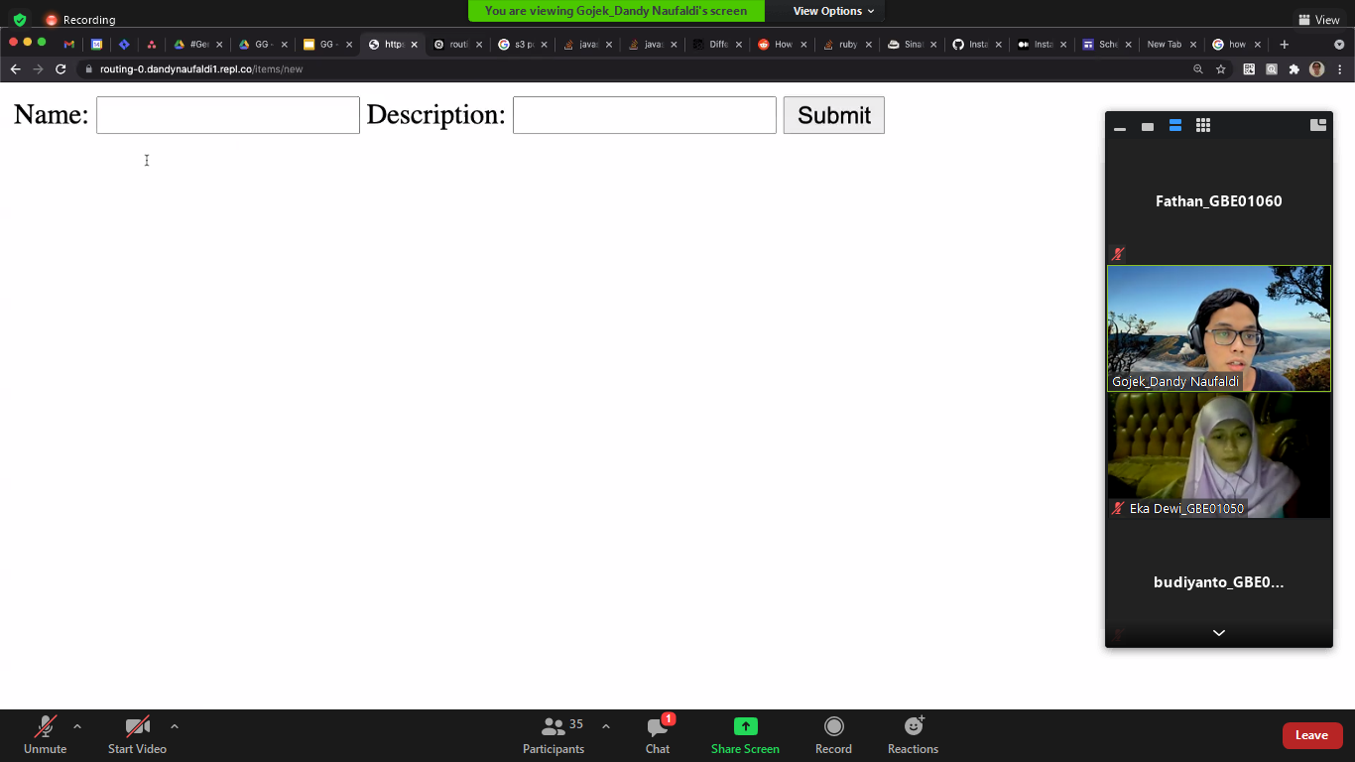

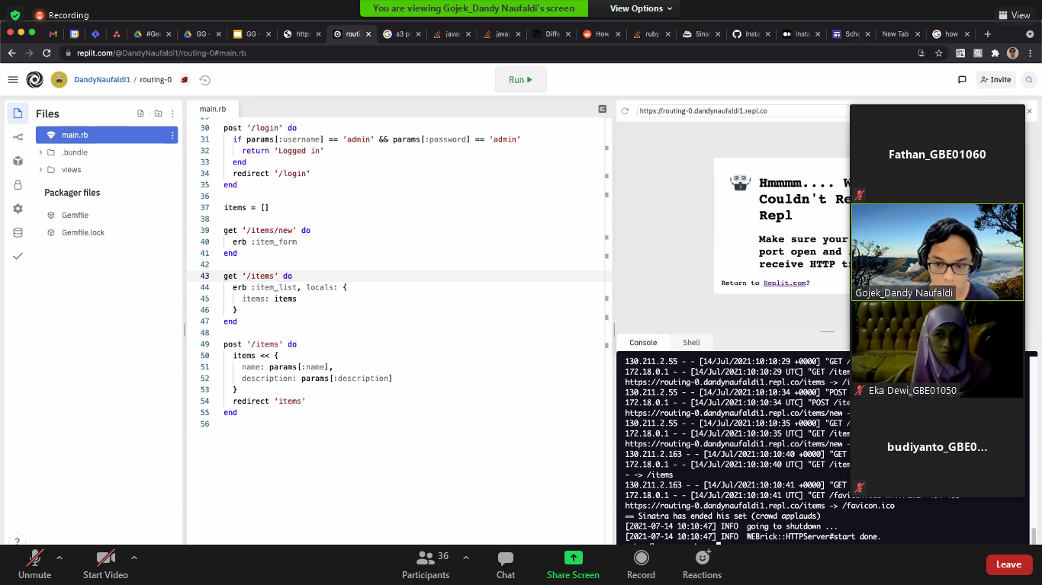

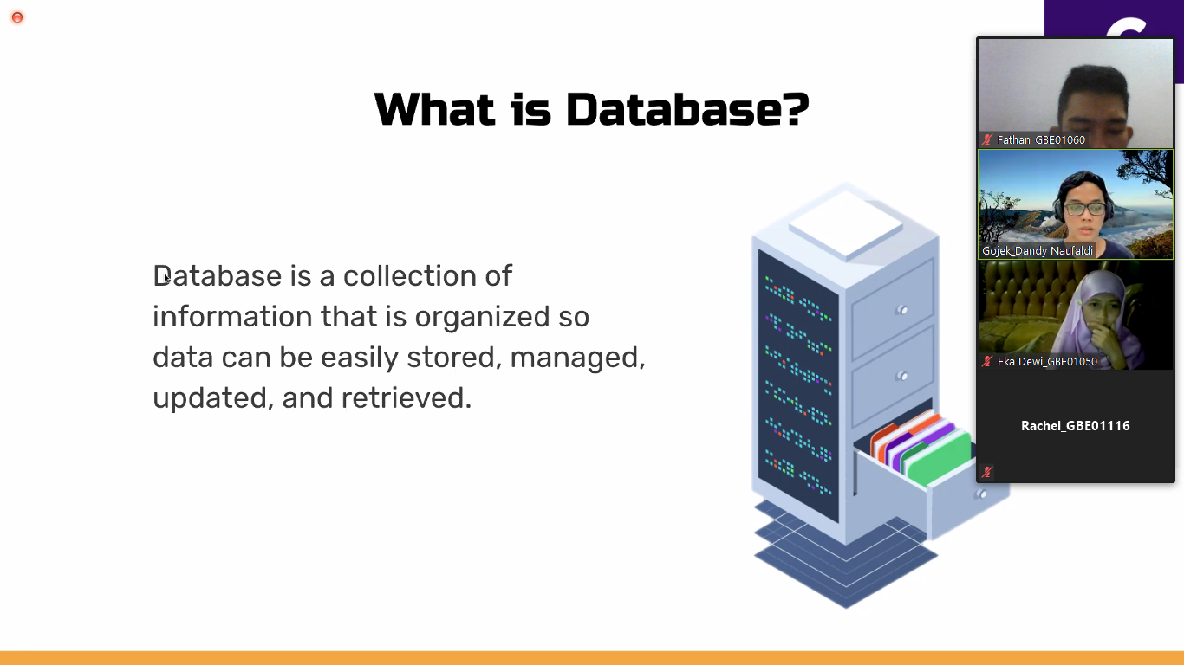

Entitas = table

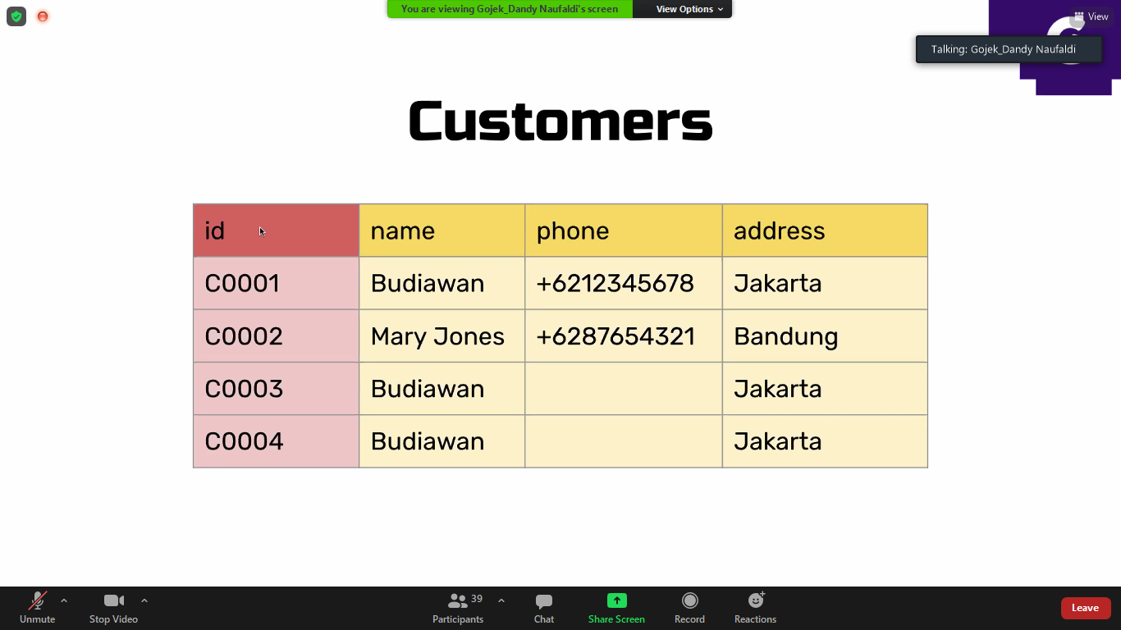

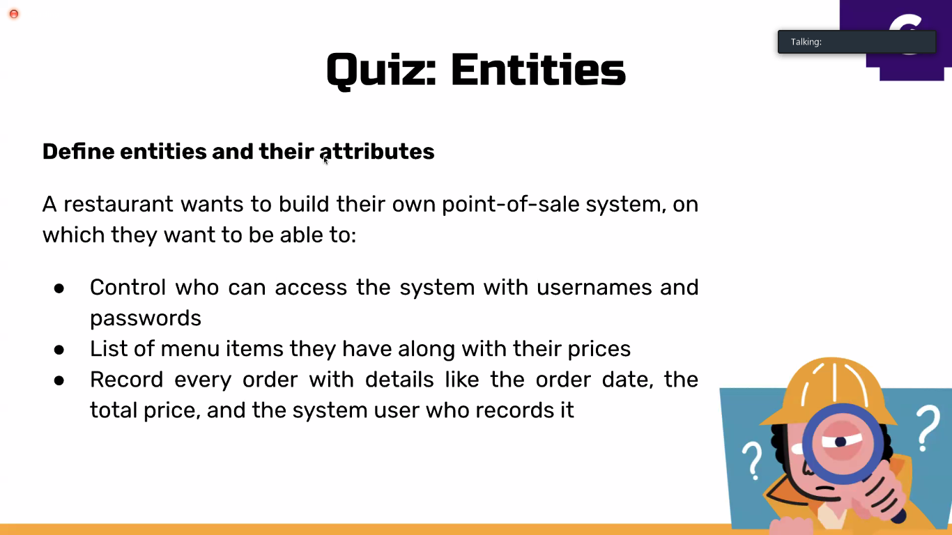

Kalo kaya gini cuman 3 doang, gaada order detail

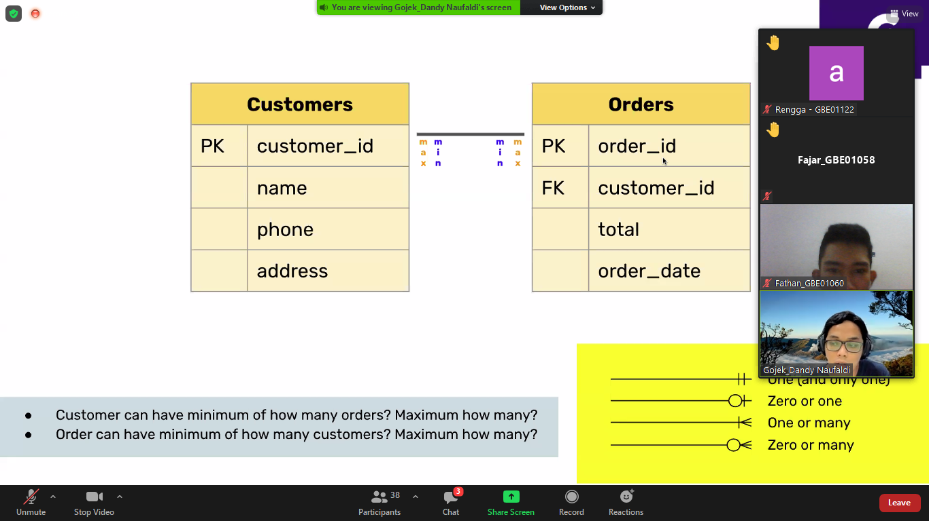

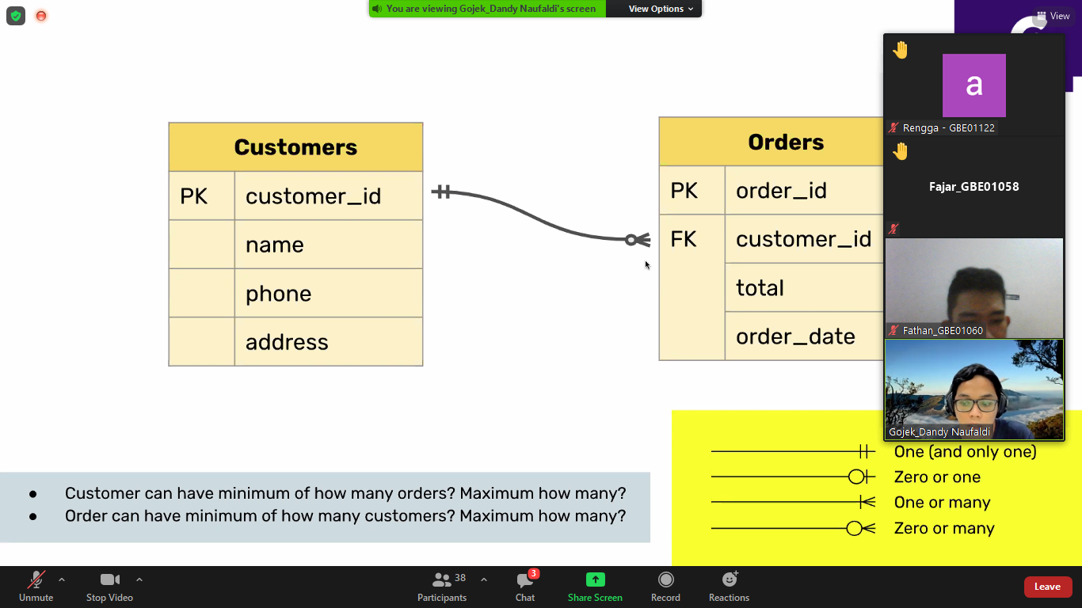

1 max bebas

1 max bebas

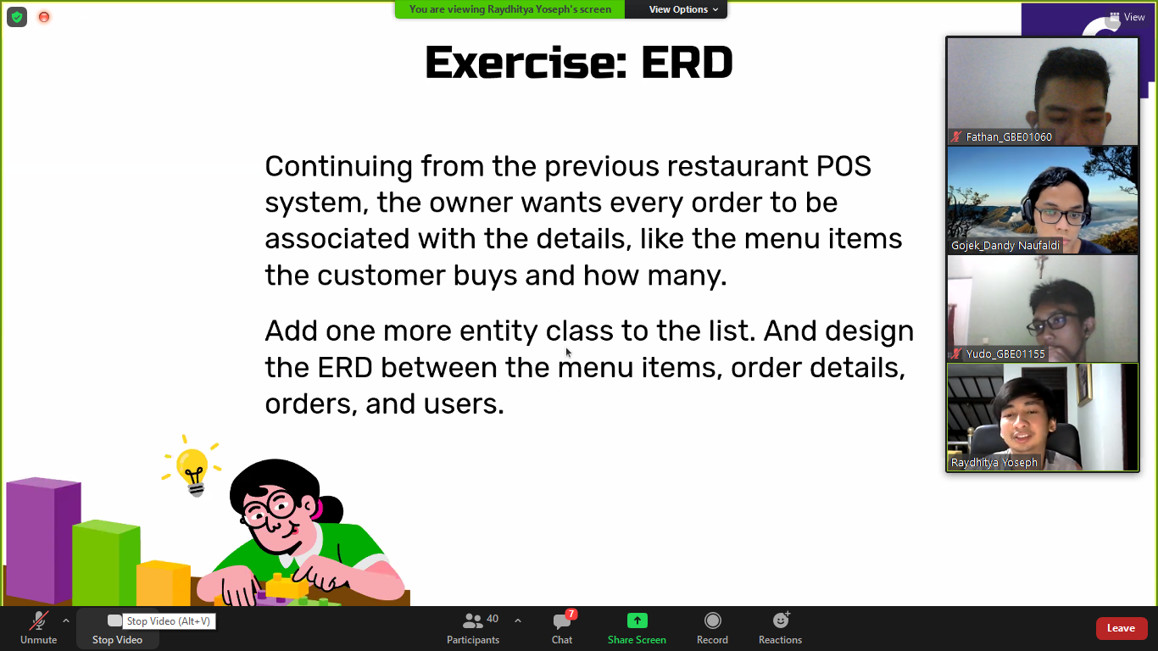

|  |  |  |  |  |
| --- | --- | --- | --- | --- |
| user |  | product |  |  |
| id(pk) |  | id(pk) |  |  |
| usermae |  | name |  |  |
| password |  | price |  |  |
| role |  |  |  |  |
|  |  |  |  |  |
|  |  |  |  |  |
|  |  | Order_detail |  |  |
| order |  | Id | |  |
| id(pk) |  | Order_id |  |  |
| user_id(fk) |  | product_id(fk) | |  |
| total |  | product_price | |  |
| order_Date |  | quantitiy |  |  |
|  |  | total |  |  |



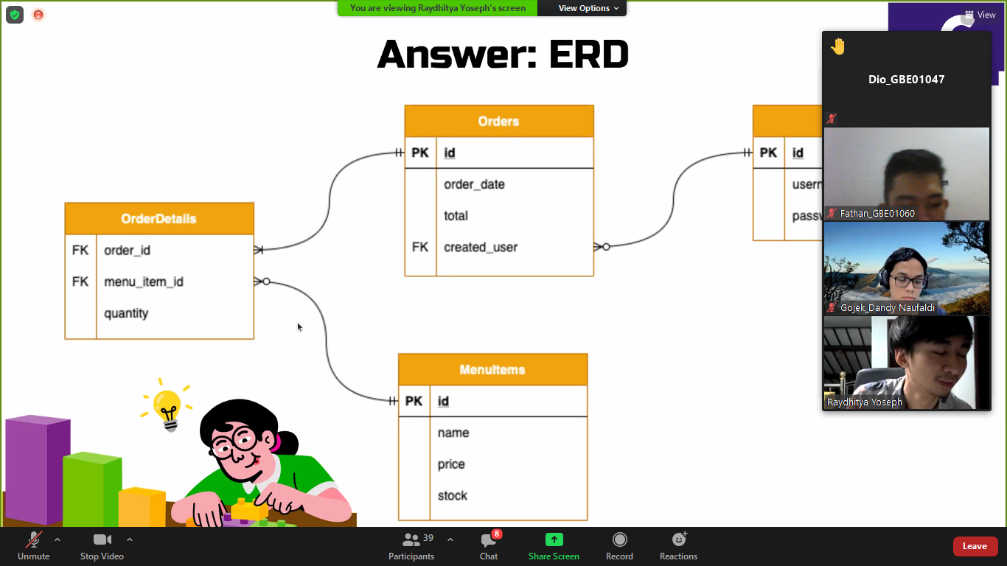

Bulet banyak

Garis bisa 1 atau null

Order tidak ada pk, karena uda unique dari 2 fk(order,menu)

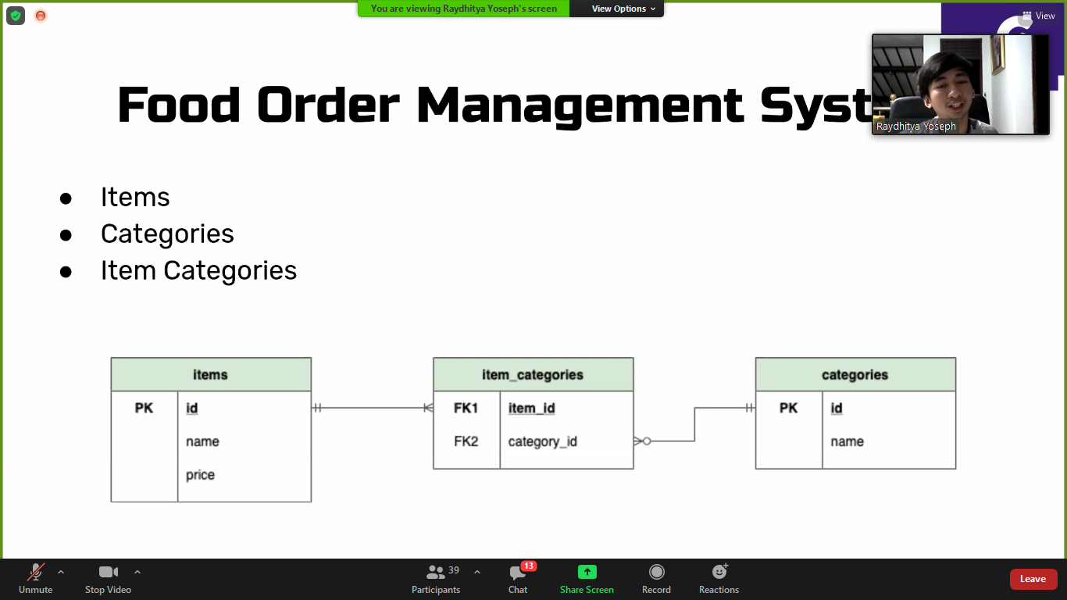

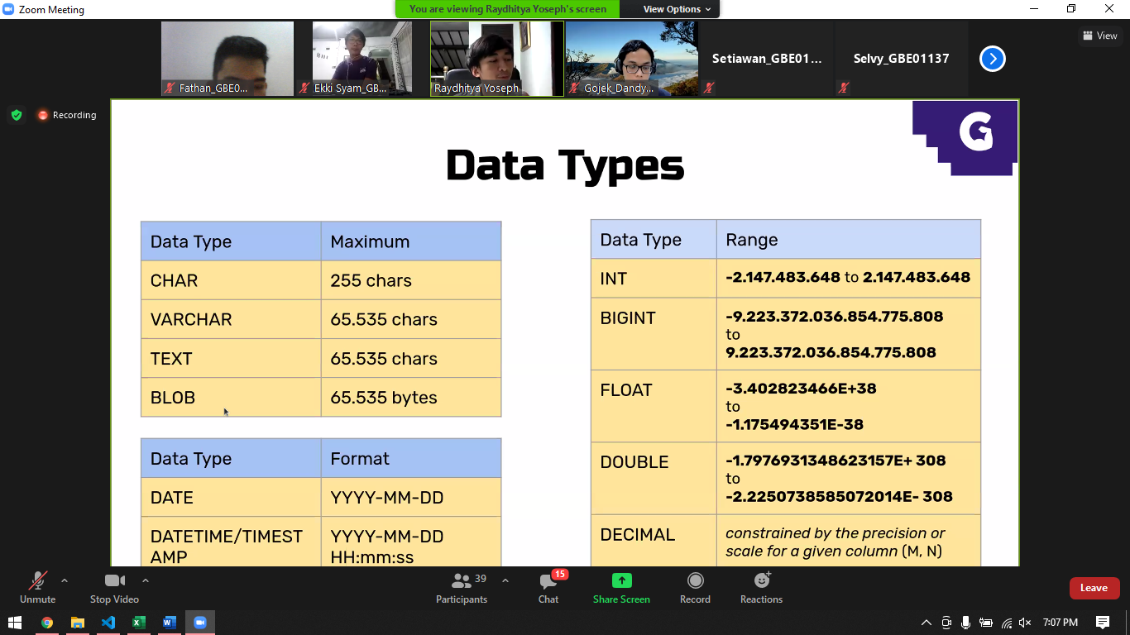

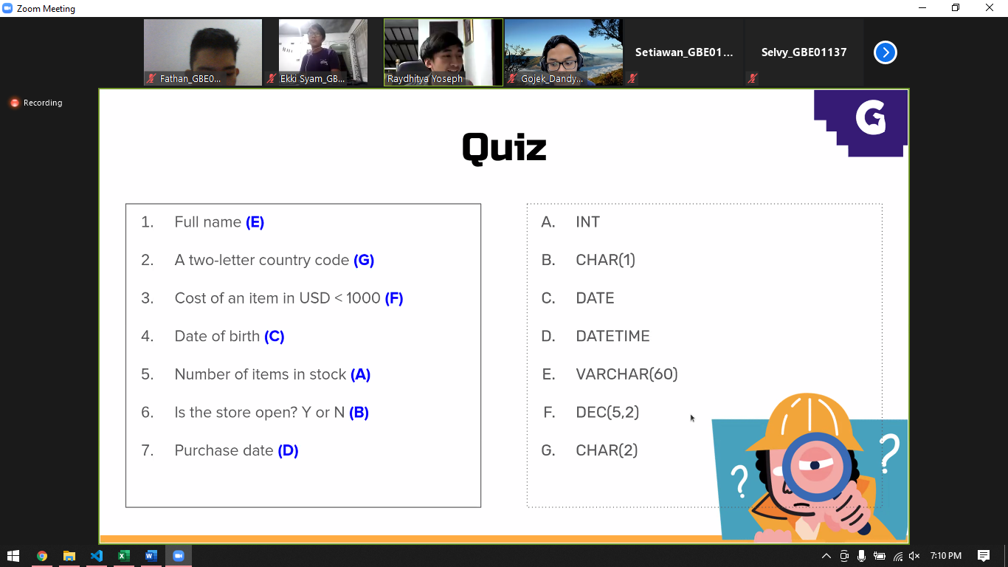

Dec(5,2) 5 angka, 2 desimalnya (999.99)

